**SMART SURVEILLANCE SYSTEM**

Report submitted in partial fulfillment of the requirement for the degree of

 B.Tech.

In

Information Technology



Under the Supervision of By

**Ms. Pooja Mudgil Arsh Singh (00720803118)  
 Rishabh Gupta (02220803118)  
 Utkarsh Sharma (03320803118)  
 Vishal Deswal (03720803118)**

BhagwanParshuram Institute of Technology

PSP-4, Sector-17, Rohini, Delhi - 89

October 2021

**Table of Contents**

INTRODUCTION 4

PROBLEM STATEMENT 5

Features: 5

Need of the Project: 5

DESIGN PHASE 7

Used Case Diagram 7

E-R Model 8

Data Flow diagram(level 0) 8

Data Flow diagram(level 1) 9

WORK DONE 10

Main menu 10

Anti Theft 10

Identify 11

Record 11

Restricted Area 12

REFERENCES 13

**tables of figures**

Figure 1:Use case diagram 7

Figure 2:ER diagram 8

Figure 3:Data flow diagram (Level 0) 8

Figure 4:Data Flow Diagram (LEVEL 1) 9

Figure 5:Main menu (Results) 10

Figure 6: Anti-theft(Results) 10

Figure 7: Identify(Results) 11

Figure 8: Record(Results) 11

Figure 9: Restricted Area (Results) 12

**CHAPTER 1**

# **INTRODUCTION**

In any public or private environment, surveillance is becoming essential in response to more and more threats. Traditional monitoring methods are usually limited to the use of closed-circuit television cameras or wireless sensor networks (WSN). These two technologies accomplish their goals in different ways. CCTV cameras help to visually monitor the target area, while WSN aids in the acquisition of physical information from the environment. Surveillance is becoming increasingly important in any public or private environment as a result of an increasing number of risks. Closed-circuit television cameras or wireless sensor networks are the most common traditional monitoring technologies (WSN). These two technologies achieve their objectives in distinct ways. WSN aids in the capture of physical information from the environment, while CCTV cameras help to visually monitor the target region.

In this project, we combined the advantages of the two technologies to build a smart surveillance system. We propose a centralized computer application that can recognize human movement in a target area and maintain visual evidence of movement with the help of a camera. This is an event-based system, so it eliminates the need for continuous area monitoring.

We integrated the benefits of the two technologies in this project to create a smart surveillance system. With the use of a camera, we suggest a centralised computer programme that can recognise human movement in a particular region and keep visual proof of activity. Because this is an event-based system, it does not require continuous area monitoring.

**CHAPTER 2**

# **PROBLEM STATEMENT**

## **Features:**

### **Anti-thief:** This feature is used to find what is the thing which is stolen from the frame which is visible to the webcam. Meaning It constantly monitors the frames and checks which object or the thing from the frame has been taken away by the thief.

### **Visitors:** This is the feature which can detect if someone has entered the room or went out.

### **Normal Recording:** This is the feature which will record the video using the webcam and will save to the external storage.

### **Face Identification:** This feature is very useful feature of our minor project, It

is used to find if the person in the frame is known or not. It do this in two

steps :

1 – Find the faces in the frames

2 – Use LBPH face recognizer algorithm to predict the

person from an already trained model.

### **Restricted Area:** This feature is used to detect the motion in a restricted area where human intervention is prohibited.

## **Need of the Project:**

Existing digital video surveillance systems simply provide the technology for capturing, storing, and distributing footage, leaving the work of threat identification entirely to human operators. Studies have shown that even if such a responsibility is allocated to a dedicated and well-intentioned individual, it will not support an effective security system. Monitoring video screens is both monotonous and captivating, and most people's attention spans have devolved well below acceptable levels after only 20 minutes of viewing and assessing monitor screens. Smart surveillance systems provide a variety of advantages over traditional video surveillance systems like the power to preempt incidents or enhanced forensic capabilities through content-based several video retrieval. The level of information necessary to change the security paradigm from investigation to prevention. Visual analysis technologies have the potential to shift today's video surveillance systems from an investigative to a preventative paradigm providing an extra layer of security.

**CHAPTER 3**

# **DESIGN PHASE**

## **Used Case Diagram**

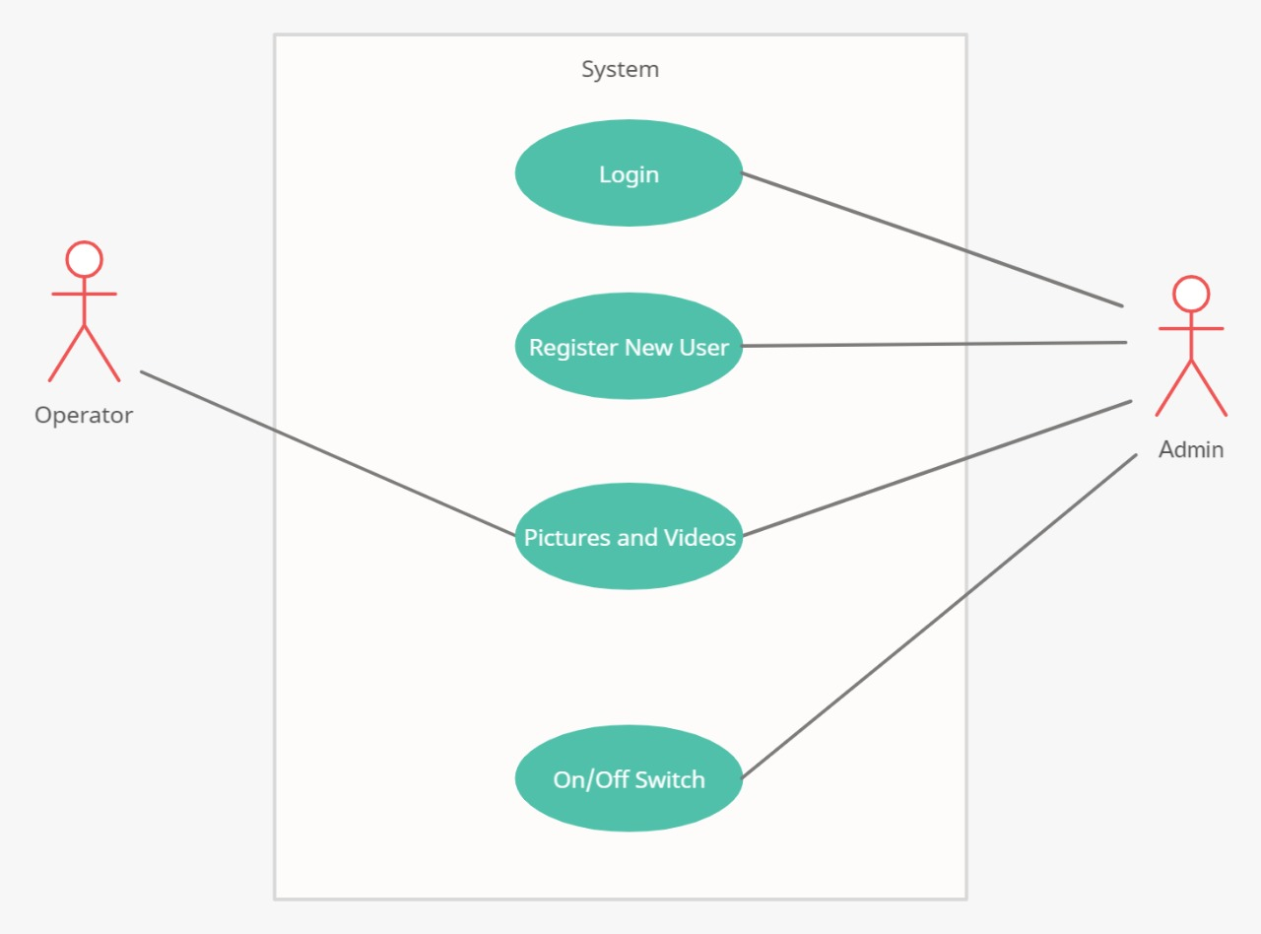Figure 1:Use case diagram

## **E-R Model**

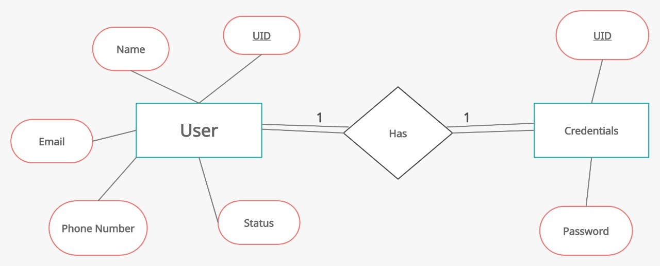

Figure 2:ER diagram

## **Data Flow diagram(level 0)**

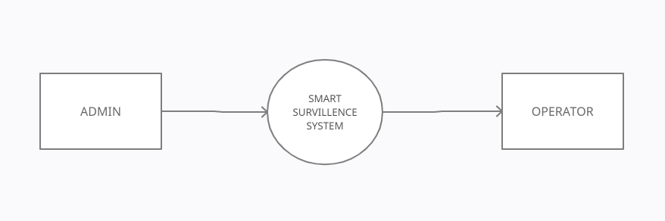

Figure 3:Data flow diagram (Level 0)

## **Data Flow diagram(level 1)**

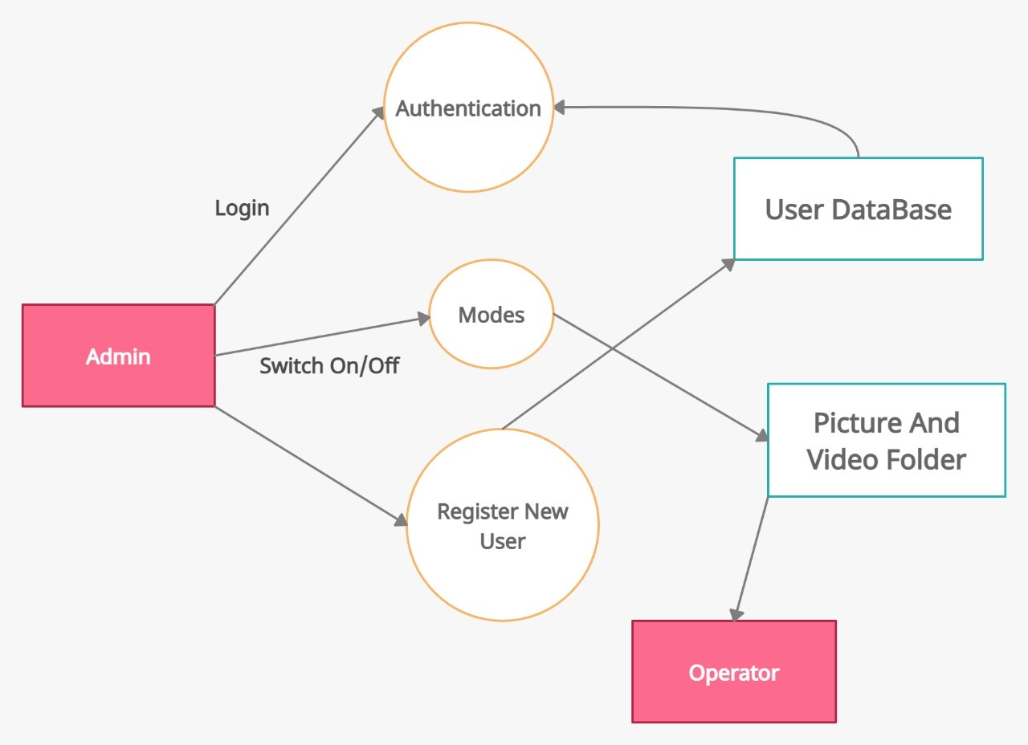

Figure 4:Data Flow Diagram (LEVEL 1)

**CHAPTER 4**

# **WORK DONE**

## **Main menu**

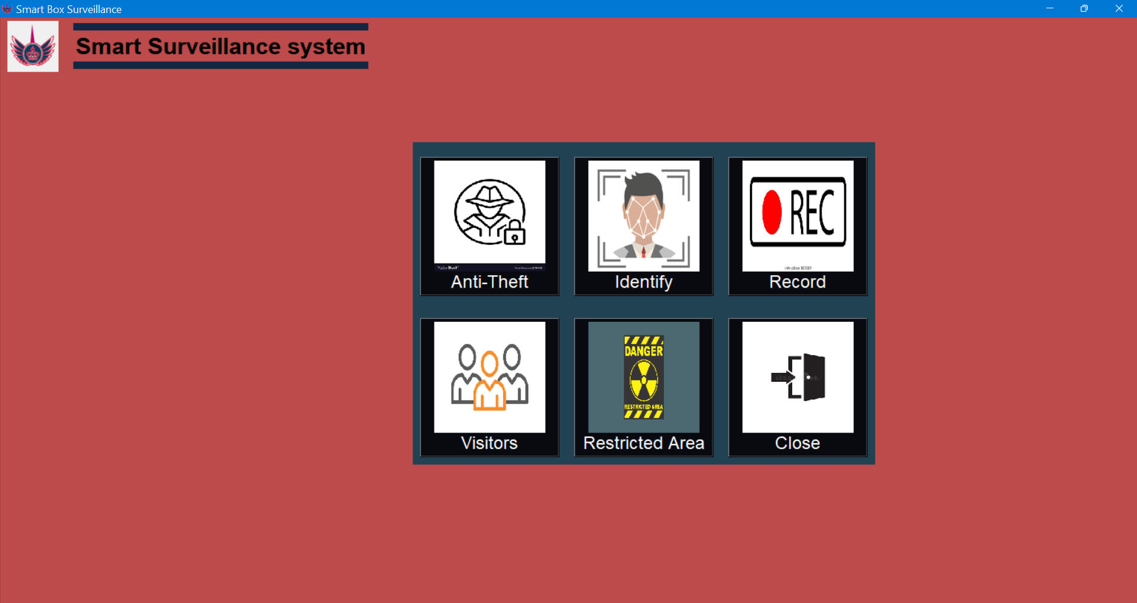

Figure 5:Main menu (Results)

## **Anti Theft**

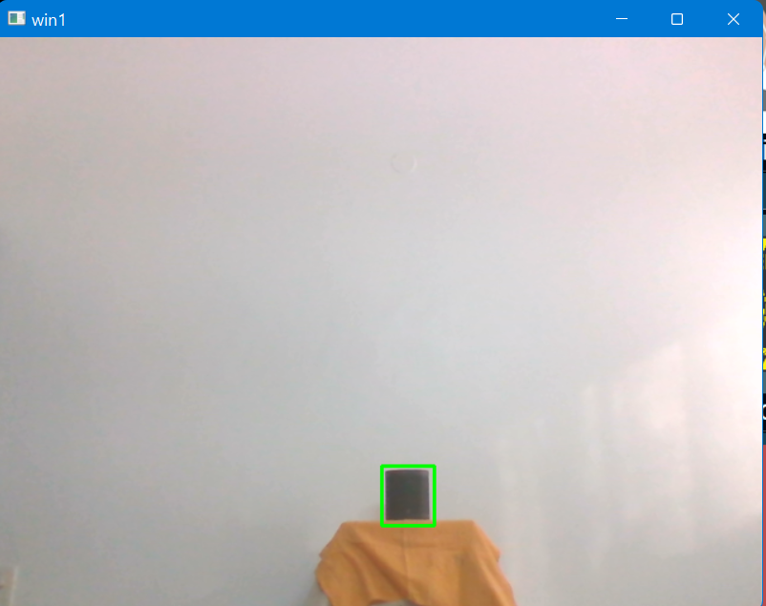

Figure 6: Anti-theft(Results)

## **Identify**

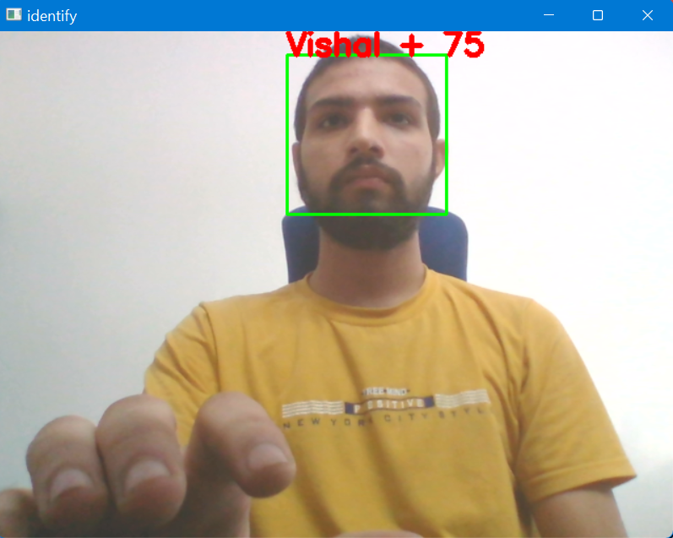

Figure 7: Identify(Results)

## **Record**

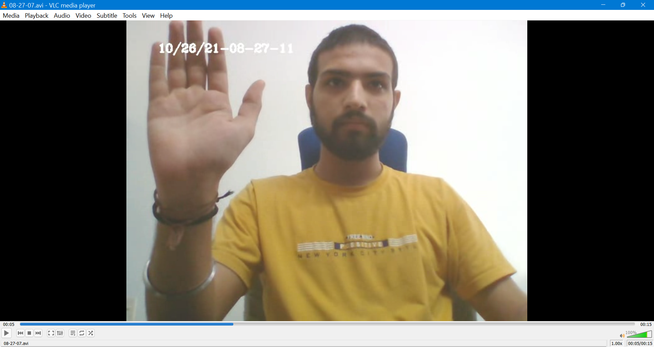

Figure 8: Record(Results)

## 

## **Restricted Area**

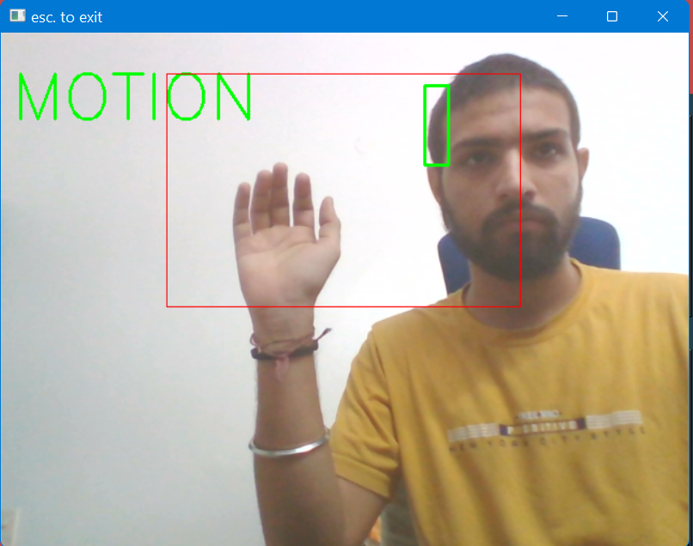

Figure 9: Restricted Area (Results)

**CHAPTER 5**

# **REFERENCES**

1. <https://www.geeksforgeeks.org/opencv-overview/>
2. <https://docs.opencv.org/2.4.13.7/>
3. <https://www.tutorialspoint.com/python3/python_gui_programming.htm>
4. <https://docs.python.org/3/library/tkinter.html>
5. <https://www.journaldev.com/48165/tkinter-working-with-classes>